Directions to the PRP Workshop October 14-16, Atkinson Hall, UC San Diego
If you are driving, put “Hopkins Parking Structure, La Jolla, CA” as your destination.
(Do not go to “UCSD 9500 Gilman Drive” which is on the other side of campus.)

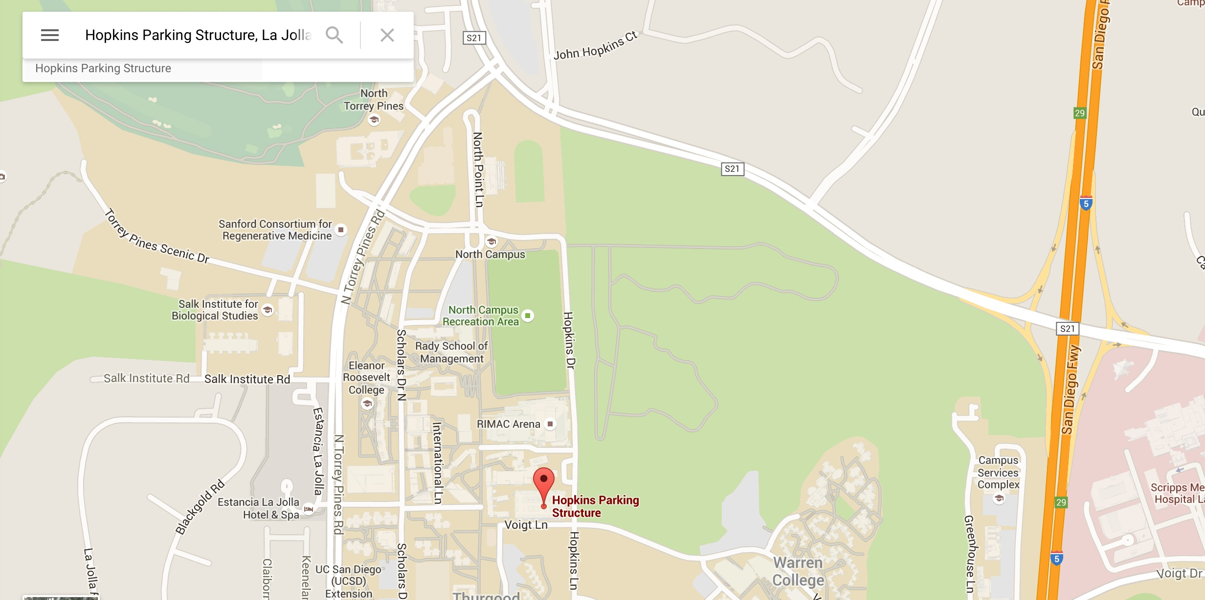
Driving: note I-5 to the right. Park in the Hopkins Parking Structure.

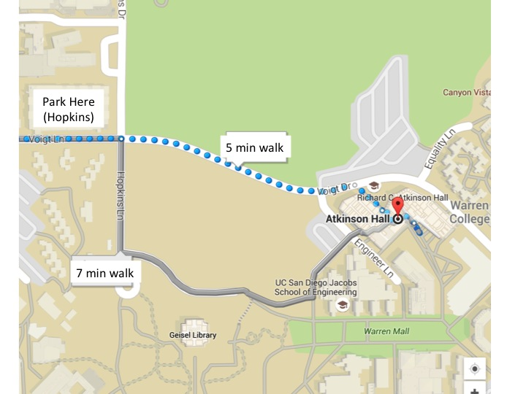
Then walk to Atkinson Hall, first floor Auditorium

If you are walking from the Sheraton Hotel:

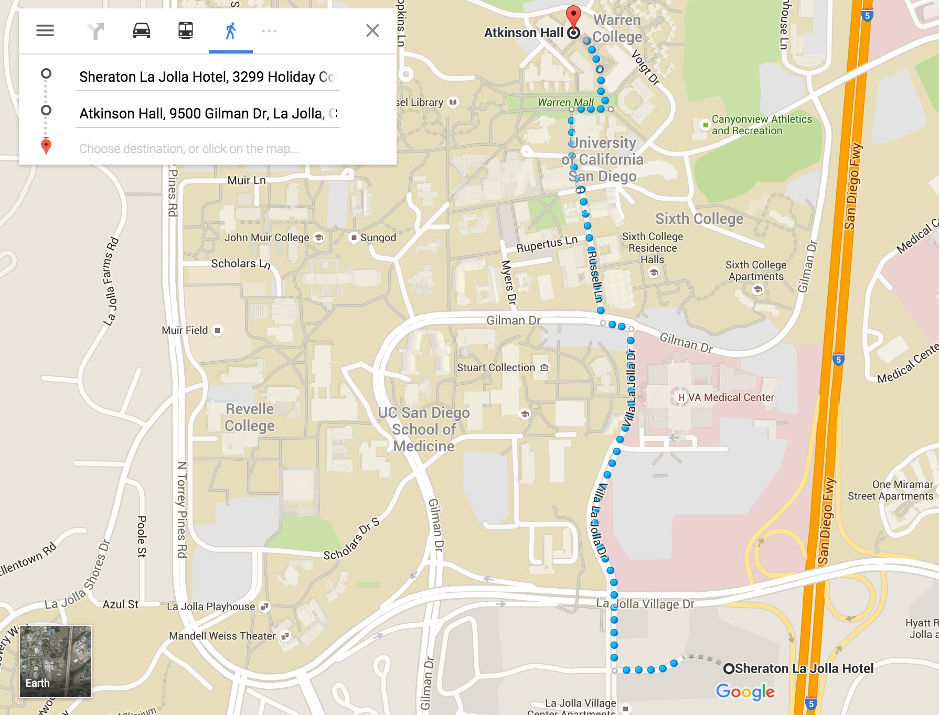

If you are walking from the Estancia Hotel:

